How to create a folder and file in window and also view that file in window view by using python ?

This is the code for creating folder and files in windows and also view this file data in window view format in python.

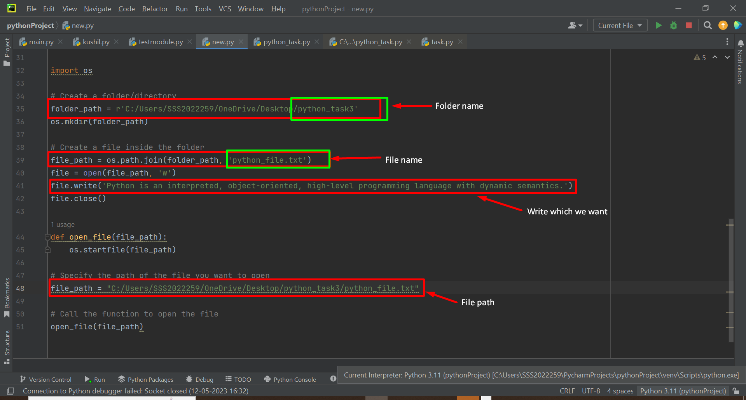

Here in this desktop Python_task3 Folder is not present.

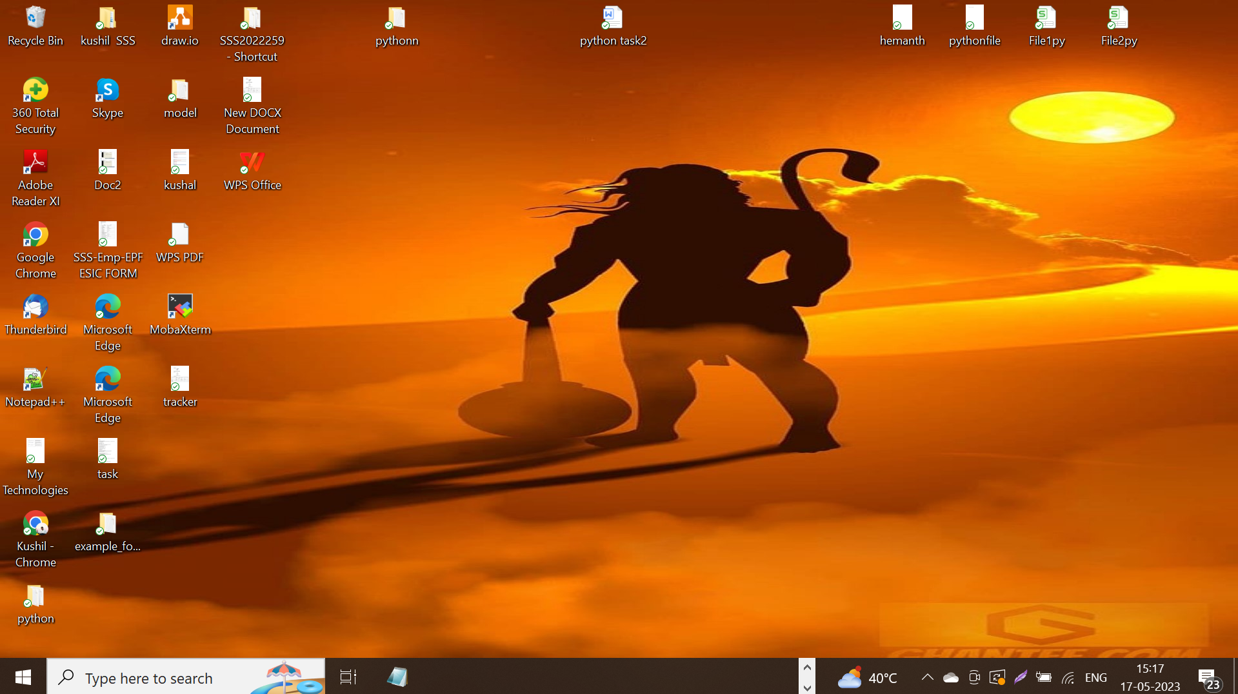

Now we execute that code.
we successfully created Folder and files in desktop and also we display that file data in the form of window view in python.

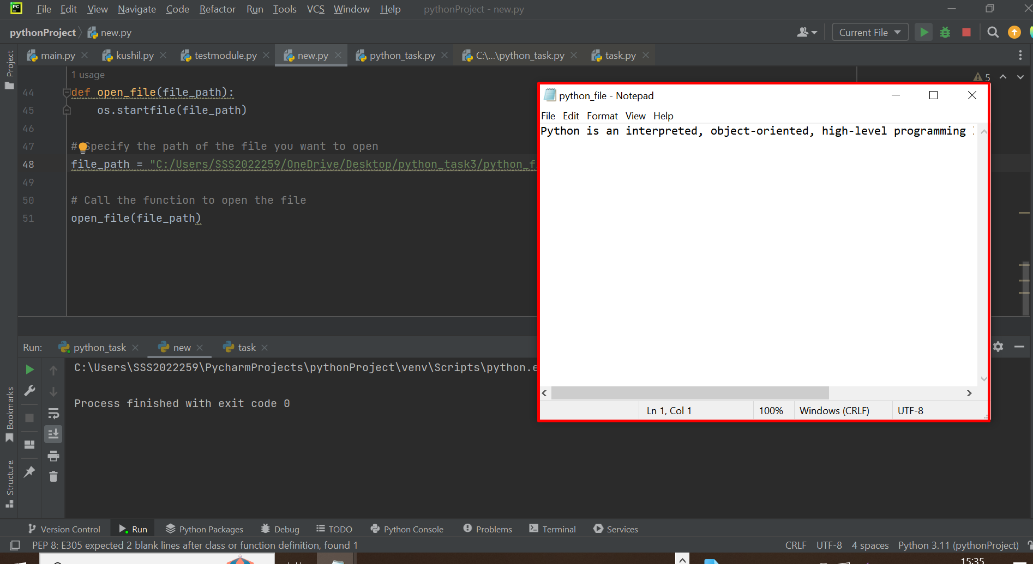

Now we see that python_task3 folder in desktop and click on that folder.

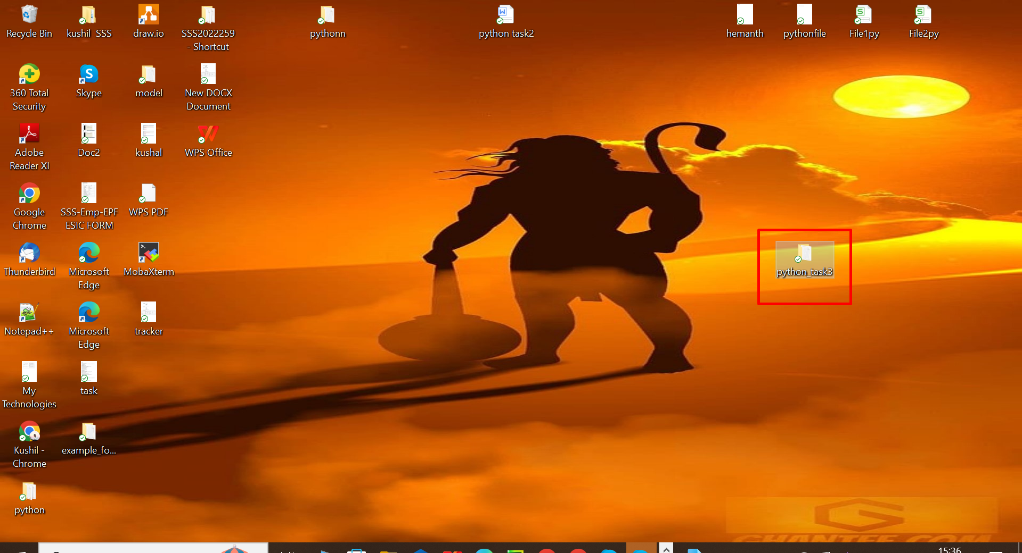

Now we see that Python file in python_task3 folder.

